- Social Media
- Apps
- Vault Apps
- Messaging, Video Chat, & Email
- Exploitation
- Sexting & Sextortion
- Cyber Bullying
- Dangers of Pornography
- Child Sex Trafficking

“Youth Safety in the Digital World”
Presented by
The Idaho Internet Crimes Against Children Task Force
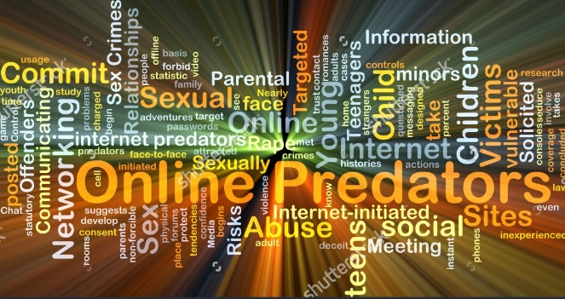

Wednesday April 17th, 2019
5:30 – 7:30 pm
PRLHS Cafeteria
596 Hwy 57
Priest River, ID

Brought to you by:
City of Priest River Police Department
The West Bonner County School District
&
The 21st Century Community Learning Center Agoge

